



DEPARTMENT OF COMPUTER SCIENCE

COMPUTER NETWORK LAB REPORT 4

Title of the Report:
Dynamic Routing in Cisco Packet Tracer

Submitted By | Submitted To | Signature
Siddhant Shrestha | Er. Sanjay Kumar Yadav
Roll. no : 024bscit040 | Computer Department
Semester: 4th | St. Xavier’s College
Section: B

Date of Submission: 08/03/2026

Lab No. 4
Title: Dynamic Routing in Cisco Packet Tracer

Lab 4.1: Routing Information Protocol (RIP) Configuration in Cisco Packet Tracer
Objective: To configure RIP and OSPF in Cisco Packet Tracer and to understand, through hands-on configuration, how each protocol lets routers discover remote networks without manual intervention.

Theory
Static routing works well for a small number of networks that do not change frequently, but it becomes difficult to manage as the network grows. Every new subnet must be manually configured on each router along the communication path. Dynamic routing protocols eliminate this manual effort by allowing routers to share information about the networks they know with each other. Each router uses this exchanged information to create and continuously update its routing table. If a link fails or a new network segment is introduced, the routers can automatically determine and converge on the most suitable routes.

Routing Information Protocol (RIP)
RIP is a distance-vector routing protocol and is one of the oldest dynamic routing protocols still used. Instead of having a complete view of the network, a RIP router relies on routing information received from its directly connected neighbors. It selects the path with the smallest number of hops as the best route. Every 30 seconds, each router sends its entire routing table to its neighboring routers. RIP considers any destination that is more than 15 hops away to be unreachable. Because of this hop-count limitation and the need to periodically exchange complete routing tables, RIP is best suited for small and relatively simple networks.

Open Shortest Path First (OSPF)
OSPF is a link-state routing protocol developed for larger and more complex networks where the limitations of RIP can become significant. Rather than depending on information received from neighboring routers, OSPF routers identify their neighbors through Hello packets and exchange Link-State Advertisements (LSAs). This process allows every router to maintain a consistent link-state database, providing a complete representation of the network topology. Each router then independently applies Dijkstra's Shortest Path First algorithm to determine the most efficient route to each destination, using interface cost instead of hop count as the routing metric.
Unlike RIP, OSPF does not periodically broadcast its entire routing table. Instead, it sends updates when changes occur in the network topology, allowing it to converge much more quickly after a link failure. OSPF also supports dividing a large network into multiple areas, which reduces the amount of topology information each router needs to maintain and makes the protocol more scalable as the network expands.

Addressing Plan for RIP Configuration

Router | Interface | Connected To | IP Address | Subnet Mask
Router1 | GigabitEthernet0/0 | Router2 G0/0 | 172.16.1.1 | 255.255.255.252
Router1 | GigabitEthernet0/2 | Switch0 (LAN1) | 192.168.1.1 | 255.255.255.0
Router3 | GigabitEthernet0/2 | Router2 G0/2 | 172.16.1.6 | 255.255.255.252
Router3 | GigabitEthernet0/0 | Switch1 (LAN2) | 192.168.2.1 | 255.255.255.0
Router2 | GigabitEthernet0/0 | Router1 G0/0 | 172.16.1.2 | 255.255.255.252
Router2 | GigabitEthernet0/2 | Router3 G0/2 | 172.16.1.5 | 255.255.255.252

End Devices for RIP Topology

Device | Connected Switch | IP Address (DHCP) | Default Gateway
PC0 | Switch0 | 192.168.1.2 | 192.168.1.1
Laptop1 | Switch0 | 192.168.1.3 | 192.168.1.1
PC1 | Switch1 | 192.168.2.2 | 192.168.2.1
Laptop2 | Switch1 | 192.168.2.3 | 192.168.2.1

Components Required
- 3 x Router (2901)
- 2–3 x Switch (2960)
- 4–6 x End devices (PCs and laptops)
- Copper cross-over cables (router-to-router links)
- Copper straight-through cables (switch-to-router and switch-to-end-device links)

Procedure

Step 1: Build the Topology
- Place three routers (2911) and connect Router1 to Router2 and Router3 to Router2 using copper cross-over cables.
- Add one switch (2960) each to Router1 and Router3, connected via a straight-through cable.
- Attach one PC and one laptop to each switch, also via straight-through cable. Router2 acts purely as a transit router and has no end devices attached to it.

Output:
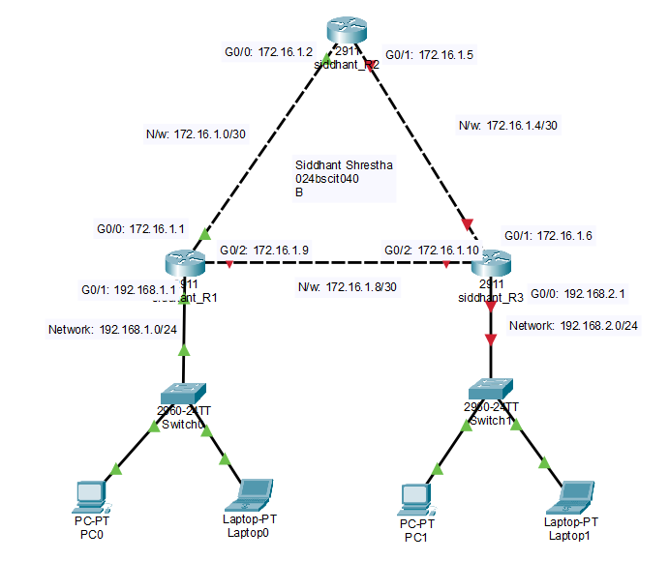

Step 2: Configure Router1's Interfaces
- Open Router1's CLI, set a hostname, and bring up the link toward Router2:
Router>en
Router#conf t
Enter configuration commands, one per line. End with CNTL/Z.
Router(config)#hostname Siddhant_R1
Siddhant_R1(config)#interface gigabitEthernet 0/0
Siddhant_R1(config-if)#ip address 172.16.1.1 255.255.255.252
Siddhant_R1(config-if)#no shutdown

Output:
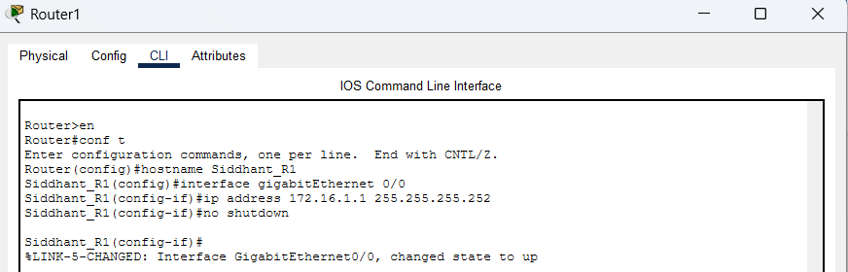

- Configure the LAN-facing interface toward Switch0:

Siddhant_R1(config-if)#exit
Siddhant_R1(config)#interface gigabitEthernet 0/2
Siddhant_R1(config-if)#ip address 192.168.1.1 255.255.255.0
Siddhant_R1(config-if)#no shutdown

Output:
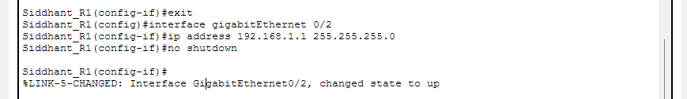

- Configure the link toward Router3:

Siddhant_R1(config-if)#exit
Siddhant_R1(config)#interface gigabitEthernet 0/1
Siddhant_R1(config-if)#ip address 172.16.1.9 255.255.255.252
Siddhant_R1(config-if)#no shutdown

Output:
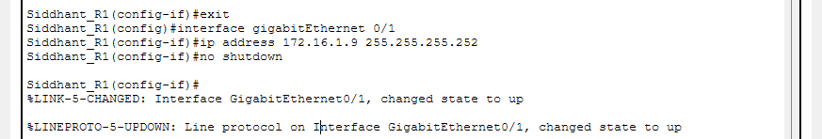

Step 3: Create Router1's DHCP Pool
- Still in global configuration mode, set up a DHCP pool for the LAN1 subnet, including the default gateway and DNS server, then save the configuration:
Siddhant_R1(config-if)#exit
Siddhant_R1(config)#ip dhcp pool siddhant_LAN1
Siddhant_R1(dhcp-config)#network 192.168.1.0 255.255.255.0
Siddhant_R1(dhcp-config)#default-router 192.168.1.1
Siddhant_R1(dhcp-config)#dns-server 10.10.10.10
Siddhant_R1(dhcp-config)#exit
Siddhant_R1(config)#exit
Siddhant_R1#wr

Output:
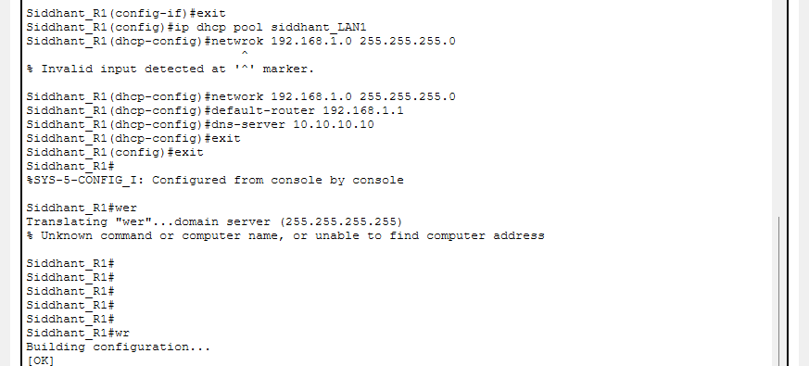

Step 4: Configure the Transit Router (Router2)
Router2 only forwards traffic between Router1 and Router3, so it needs its two point-to-point links configured and nothing more:

Router>en
Router#conf t
Enter configuration commands, one per line. End with CNTL/Z.
Router(config)#hostname Siddhant_R2
Siddhant_R2(config)#interface gigabitEthernet 0/0
Siddhant_R2(config-if)#ip address 172.16.1.2 255.255.255.252
Siddhant_R2(config-if)#no shutdown
Siddhant_R2(config-if)#exit
Siddhant_R2(config)#interface gigabitEthernet 0/2
Siddhant_R2(config-if)#ip address 172.16.1.5 255.255.255.252
Siddhant_R2(config-if)#no shutdown
Siddhant_R2(config-if)#exit
Siddhant_R2(config)#exit
Siddhant_R2#wr

Output:
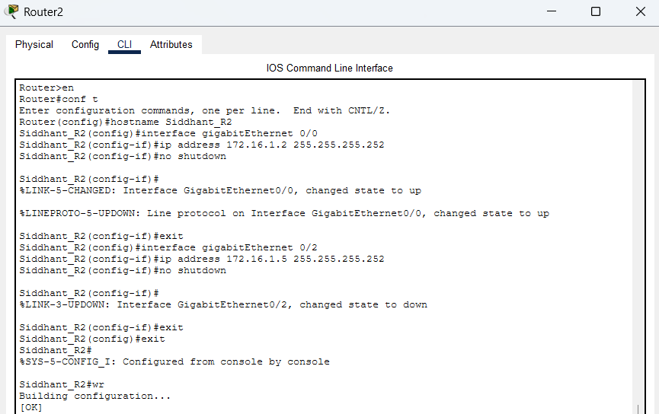

Step 5: Configure Router3's Interfaces and DHCP Pool
- Repeat the same pattern on Router3 for its own link and LAN, using a distinct hostname, its own WAN address, and a DHCP pool for the 192.168.2.0/24 network with its own DNS server:

Router>en
Router#conf t
Router(config)#hostname Siddhant_R3
Siddhant_R3(config)#interface gigabitEthernet 0/2
Siddhant_R3(config-if)#ip address 172.16.1.6 255.255.255.252
Siddhant_R3(config-if)#no shutdown
Siddhant_R3(config-if)#exit

Siddhant_R3(config)#interface gigabitEthernet 0/0
Siddhant_R3(config-if)#ip address 192.168.2.1 255.255.255.0
Siddhant_R3(config-if)#no shutdown
Siddhant_R3(config-if)#exit

Siddhant_R3(config)#interface gigabitEthernet 0/1
Siddhant_R3(config-if)#ip address 172.16.1.10 255.255.255.252
Siddhant_R3(config-if)#no shutdown
Siddhant_R3(config-if)#exit

Siddhant_R3(config)#ip dhcp pool Siddhant_LAN2
Siddhant_R3(dhcp-config)#network 192.168.2.0 255.255.255.0
Siddhant_R3(dhcp-config)#default-router 192.168.2.1
Siddhant_R3(dhcp-config)#dns-server 20.20.20.20
Siddhant_R3(dhcp-config)#exit
Siddhant_R3(config)#exit
Siddhant_R3#wr

Output:
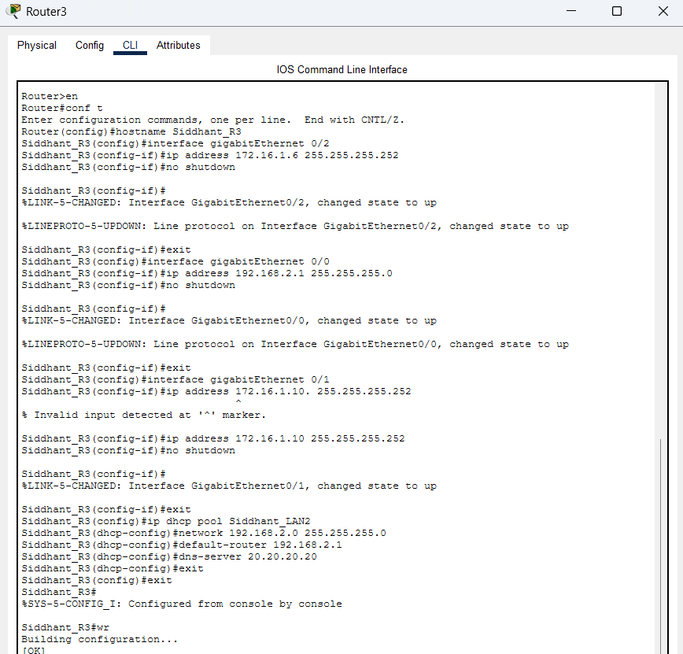

Step 6: Verify DHCP Is Reaching the Clients
- On each PC and laptop, open Desktop → IP Configuration, select DHCP, and confirm the device picks up an address, default gateway, and DNS server that match its LAN automatically.

Output:
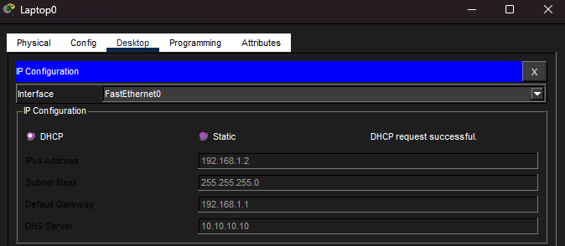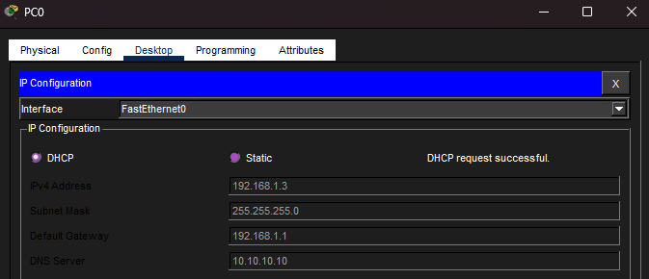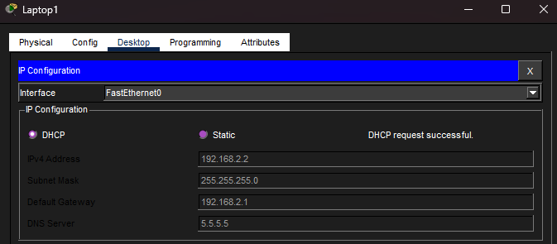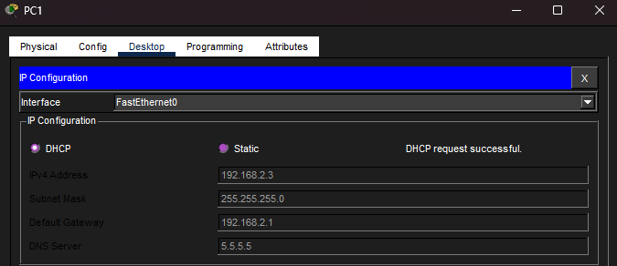

Step 7: Test Network Connectivity
- Open PC1 → Desktop → Command Prompt.
- Ping 192.168.2.1, this should succeed, confirming the default gateway is reachable.
- Ping 172.16.1.9 and it return "Destination host unreachable" since RIP has not been enabled yet.
- Ping 172.16.1.5, which returns "Request timed out."
- At this stage only the default gateway responds; every other destination is unreachable or unresponsive because no routing protocol is running yet.

Output:
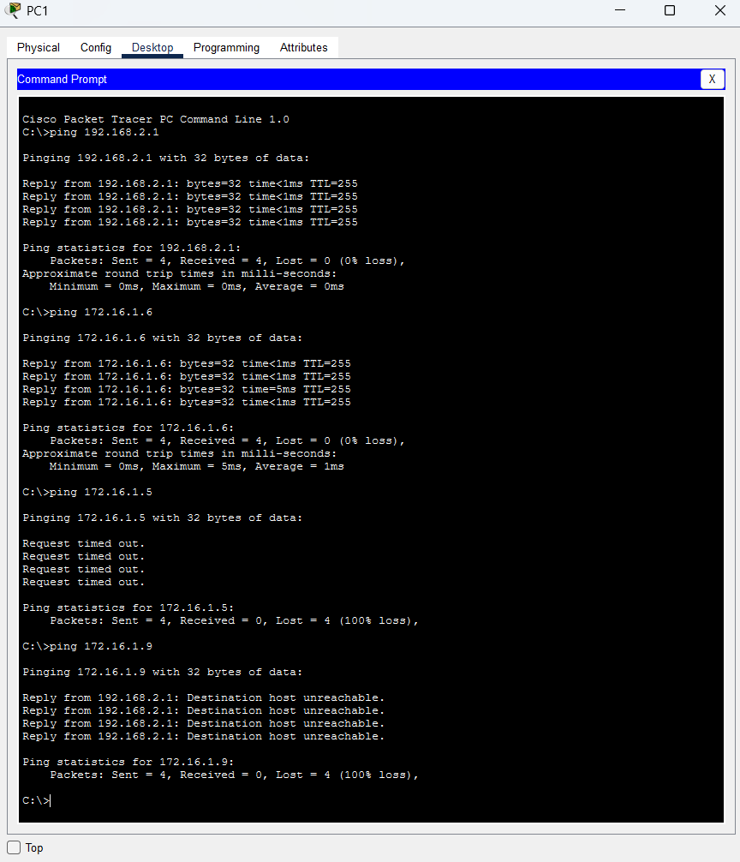

Step 8: Enable RIP on All Three Routers
- On each router, enter RIP router-configuration mode, set version 2, and advertise every network directly connected to that router:

Siddhant_R1>en
Siddhant_R1#conf t
Siddhant_R1(config)#router rip
Siddhant_R1(config-router)#version 2
Siddhant_R1(config-router)#network 172.16.1.0
Siddhant_R1(config-router)#network 172.16.1.8
Siddhant_R1(config-router)#network 192.168.1.0
Siddhant_R1(config-router)#exit
Siddhant_R1(config)#exit

Siddhant_R2>en
Siddhant_R2#conf t
Siddhant_R2(config)#router rip
Siddhant_R2(config-router)#version 2
Siddhant_R2(config-router)#network 172.16.1.0
Siddhant_R2(config-router)#network 172.16.1.4
Siddhant_R2(config-router)#exit
Siddhant_R2(config)#exit

Router>en
Router#conf t
Router(config)#router rip
Router(config-router)#version 2
Router(config-router)#network 172.16.1.4
Router(config-router)#network 172.16.1.8
Router(config-router)#network 172.16.2.0
Router(config-router)#exit
Router(config)#exit

- Save each router's configuration with wr.

Output:

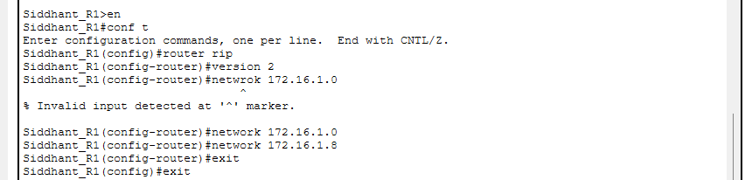

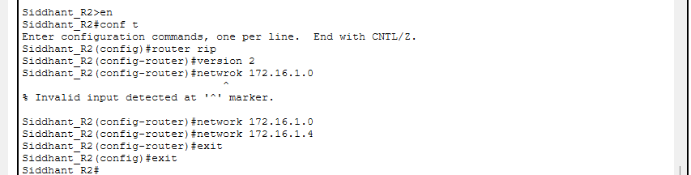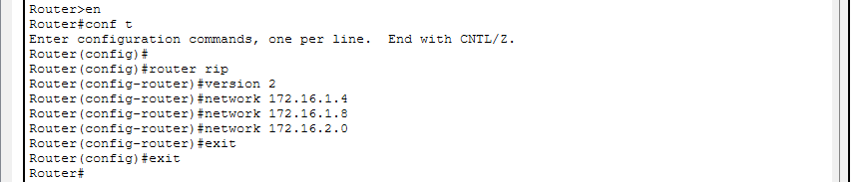

Step 9: Confirm the Learned Routes
- On each router, run show ip route and look for entries marked R, these are the routes RIP learned automatically, as opposed to the C/L entries for directly connected interfaces.

Output:

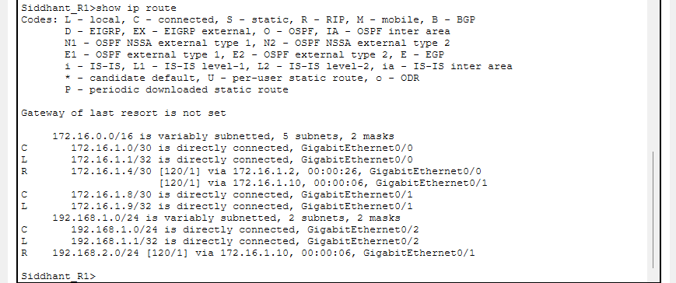

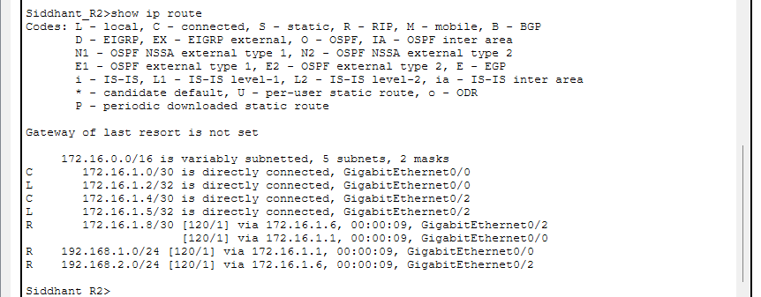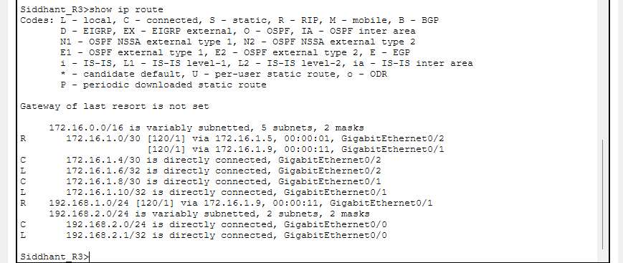

Step 10: Test End-to-End Connectivity
- From Siddhant_R3, ping a device on the far LAN:

Siddhant_R3#ping 172.16.1.1

Siddhant_R3#ping 172.16.1.2

Siddhant_R3#ping 172.16.1.5

Output:
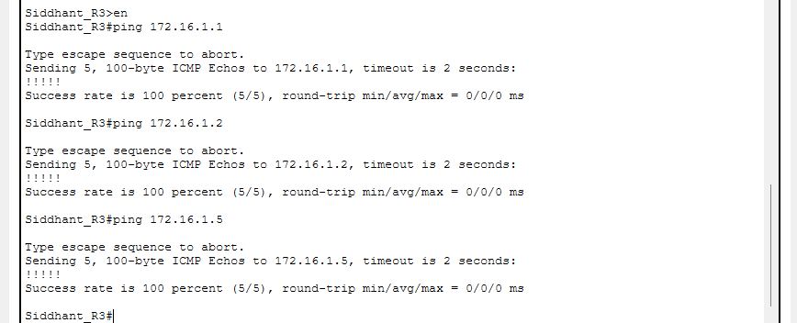

Step 11: Test Connectivity (Real-Time Simulation)
- Switch Packet Tracer into Simulation mode and send a test packet between two end devices on opposite LANs to watch it hop through Router1, Router2, and Router3 based purely on the RIP-learned routes.

Output:

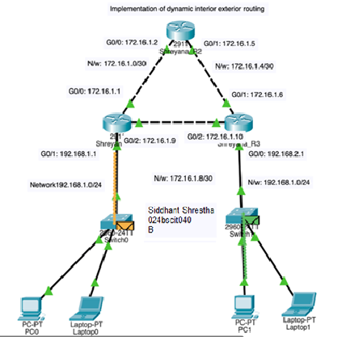

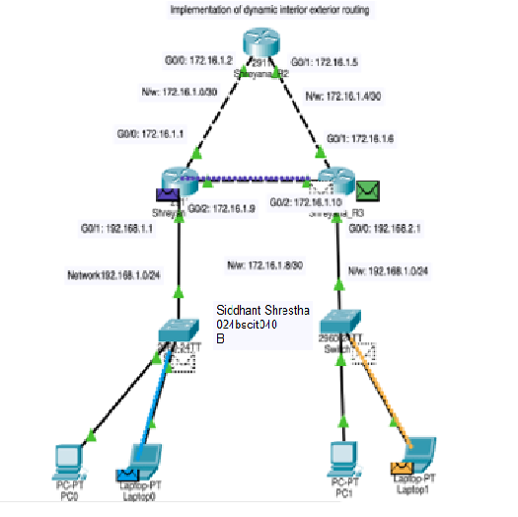

CONCLUSION (Lab 4.1):

This lab replaced manual routes with RIPv2 on a three-router, fully meshed topology. After each router's interfaces, hostname, and DHCP pool were configured and verified, RIPv2 was enabled on all three routers; its routing table showed each remote network learned with the R code and a simple hop-count metric, and its network statement needed only the classful address, with no wildcard mask or area. Full connectivity was verified between all three routers and across all three LANs, first from the CLI with ping and then visually in Simulation Mode, confirming that RIP successfully replaced static routing on this topology.

Lab 4.2: Open Shortest Path First (OSPF) Configuration in Cisco Packet Tracer

Addressing Plan (OSPF)

Router | Interface | Connected To | IP Address | Subnet Mask
R0 | G0/0 | R1 G0/0 | 172.16.1.1 | 255.255.255.252
R0 | G0/1 | R2 G0/1 | 172.16.1.9 | 255.255.255.252
R0 | G0/2 | Switch0 (LAN1) | 192.168.1.1 | 255.255.255.0
R1 | G0/0 | R0 G0/0 | 172.16.1.2 | 255.255.255.252
R1 | G0/1 | R2 G0/0 | 172.16.1.5 | 255.255.255.252
R1 | G0/2 | Switch1 (LAN2) | 192.168.2.1 | 255.255.255.0
R2 | G0/2 | R1 G0/2 | 172.16.1.6 | 255.255.255.252
R2 | G0/1 | R0 G0/1 | 172.16.1.10 | 255.255.255.252
R2 | G0/0 | Switch2 (LAN3) | 192.168.3.1 | 255.255.255.0

End Devices: OSPF Topology

Device | Connected Switch | IP Address (DHCP) | Default Gateway
PC0 | Switch0 | 192.168.1.2 | 192.168.1.1
Laptop0 | Switch0 | 192.168.1.3 | 192.168.1.1
PC1 | Switch1 | 192.168.2.2 | 192.168.2.1
Laptop1 | Switch1 | 192.168.2.3 | 192.168.2.1

PC2 | Switch2 | 192.168.3.2 | 192.168.3.1
Laptop2 | Switch2 | 192.168.3.3 | 192.168.3.1

Procedure

Step 1: Build the Triangle Topology
- Place three routers (2911) and connect every pair directly, R0–R1, R1–R2, and R2–R0, with copper cross-over cables, forming a full triangle.
- Attach one switch (2960) to each router, and one PC plus one laptop to each switch, using straight-through cables throughout.

Output:
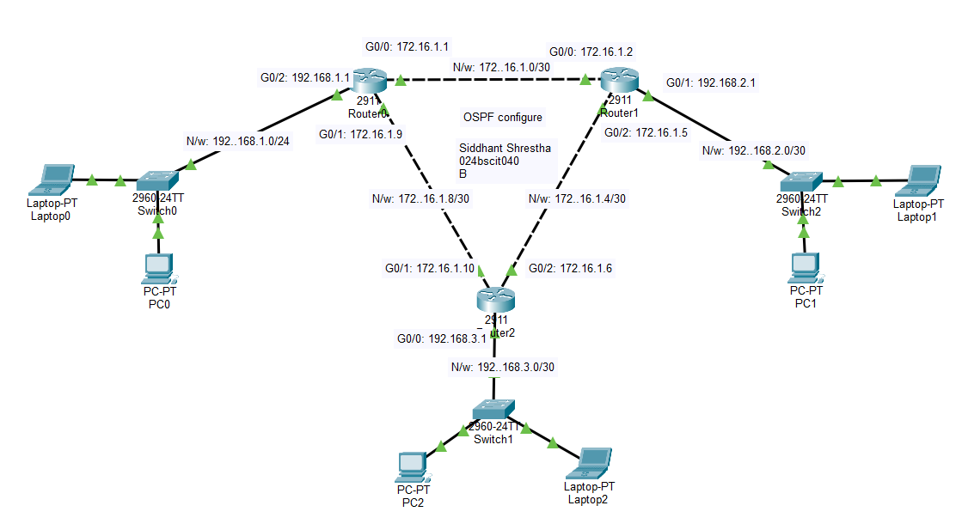

Step 2: Configure IP Addressing on All Three Routers
- On each router, configure the two inter-router links and the LAN-facing interface using the addressing plan above:
enable conf t
hostname prashant_R0 interface gigabitEthernet 0/0
ip address 172.16.1.1 255.255.255.252

no shutdown exit
interface gigabitEthernet 0/1
ip address 192.168.1.1 255.255.255.0
no shutdown exit
interface gigabitEthernet 0/2
ip address 172.16.1.10 255.255.255.252
no shutdown

- Repeat the equivalent addressing on R1 and R2 (hostnames prashant_R1 and prashant_R2), using their own rows from the table above.

Output:
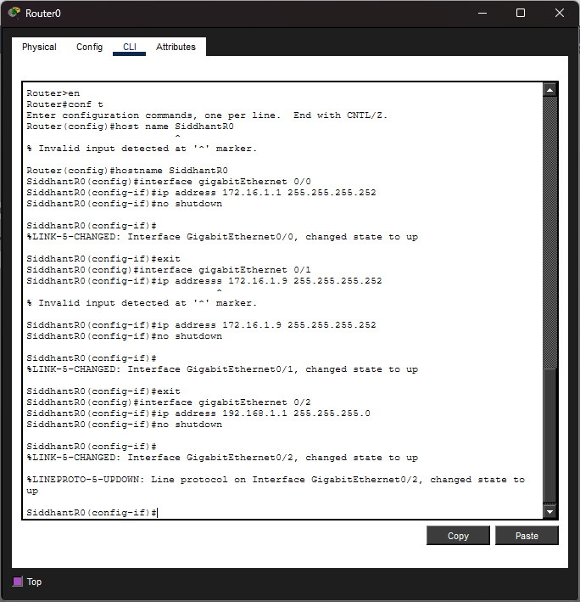

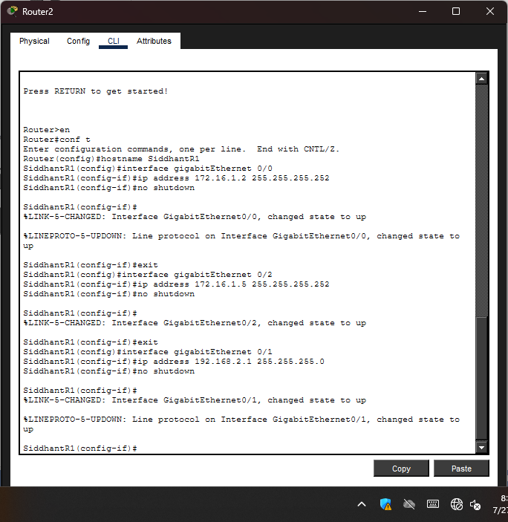
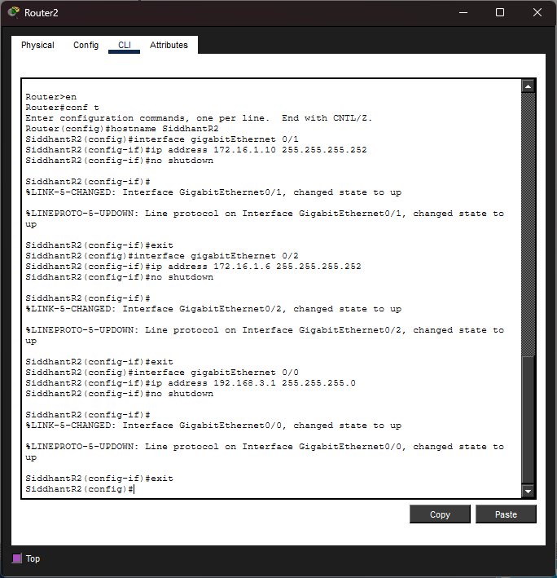

Step 3: Create a DHCP Pool on Each Router
- Each router hands out addresses only for its own local LAN, using a distinct DNS server per LAN so they stay easy to tell apart:
exit
ip dhcp pool prashant_LAN01 network 192.168.1.0 255.255.255.0
default-router 192.168.1.1
dns-server 10.10.10.10 exit
exit wr

- R1 and R2 follow the same pattern for 192.168.2.0/24 (DNS 5.5.5.5) and 192.168.3.0/24 (DNS 20.20.20.20) respectively.

Output:
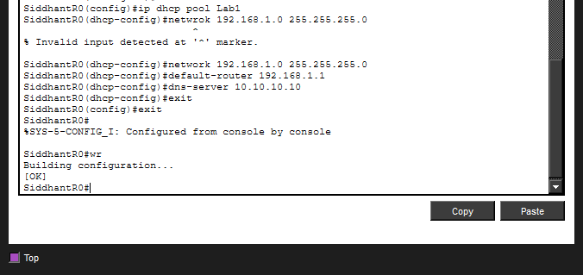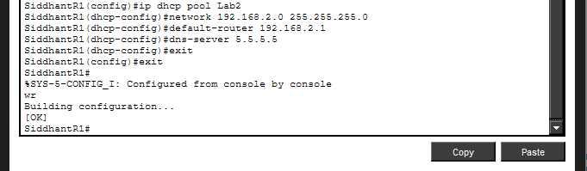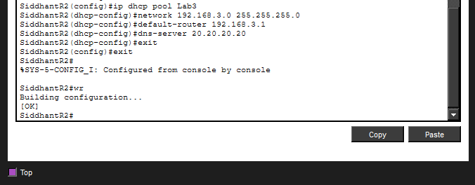

Step 4: Enable OSPF and Advertise Every Connected Network
- On each router, start an OSPF process and advertise every directly connected network, using the correct wildcard mask for each subnet size and placing everything in Area 0:
router ospf 1
network <network address> <wildcard mask> area 0
- Wildcard masks: a /30 point-to-point link uses 0.0.0.3, and a /24 LAN uses 0.0.0.255, the inverse of the subnet mask in each case.
- Each router advertises three networks this way: its two router-to-router links and its own LAN.

Output:

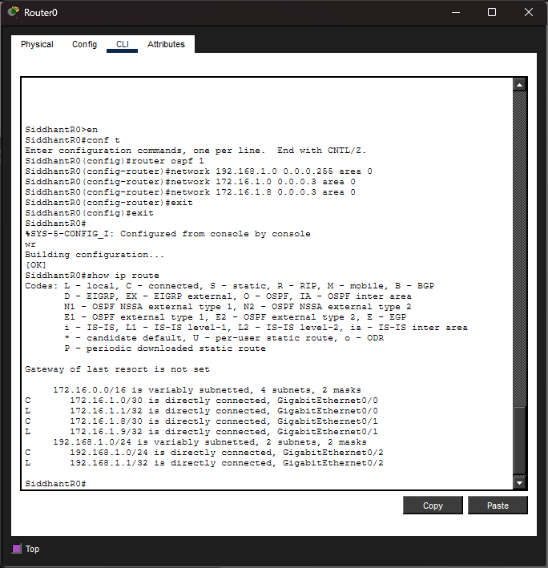

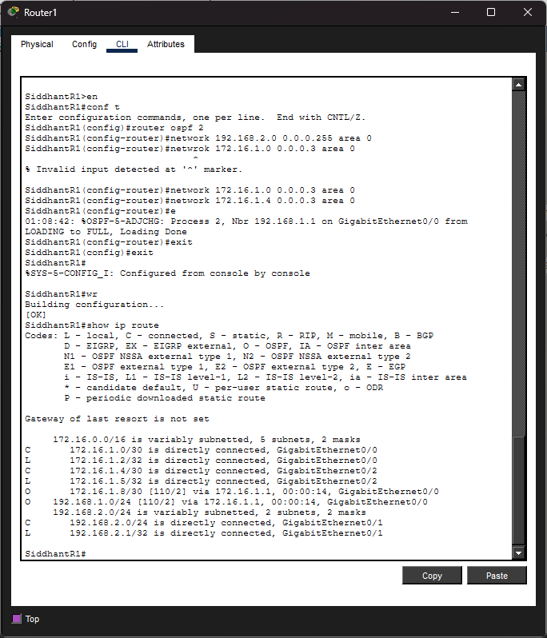

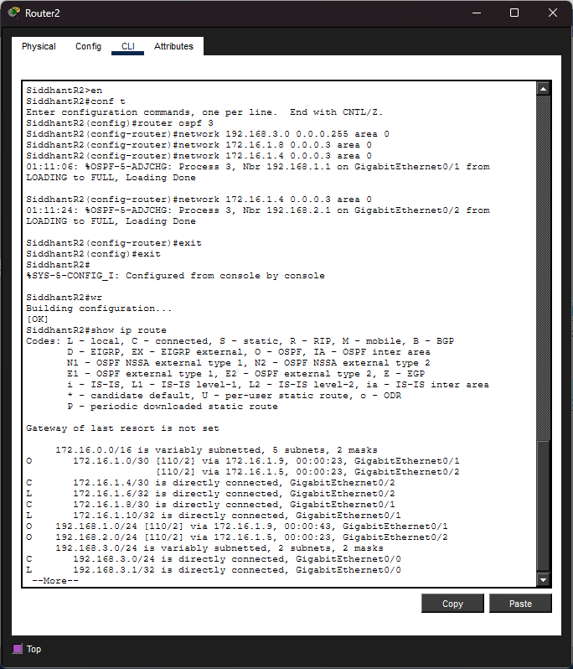

Step 5: Confirm OSPF Has Formed Neighbor Relationships
- On any router, run:
show ip ospf neighbor

Output:

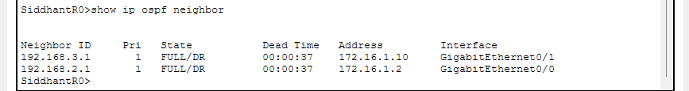

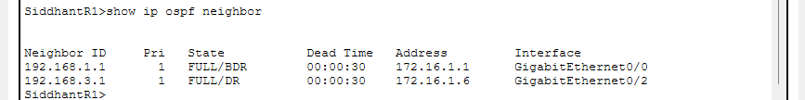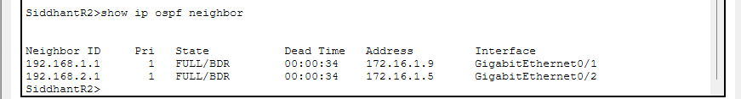

Step 6: Test Connectivity Across All Three LANs
- From PC0 (LAN1), ping a device on LAN2:
ping 192.168.2.2

Output:

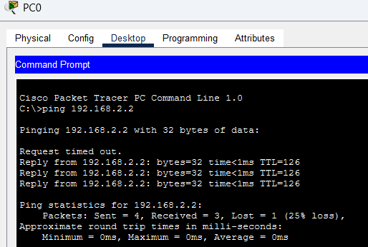

Conclusion:
In the OSPF topology, the three routers established neighbor relationships and exchanged routing information based on link costs. The routing tables showed that the routers successfully learned the shortest available paths to the connected LANs. Successful ping tests between the hosts further confirmed proper end-to-end connectivity, demonstrating that dynamic routing can efficiently manage network communication without manual route configuration.
This lab demonstrated the use of dynamic routing protocols, RIP and OSPF, as an alternative to manually configured static routes. In the RIP topology, routers automatically learned about remote networks by exchanging information about their directly connected networks. This removed the need to configure individual static routes, and after RIP successfully converged, devices on different ends of the network were able to communicate properly.

